Erwin Technical College

Seeking full-time instructor for Medical Clinical Laboratory Technician program. Courses include:
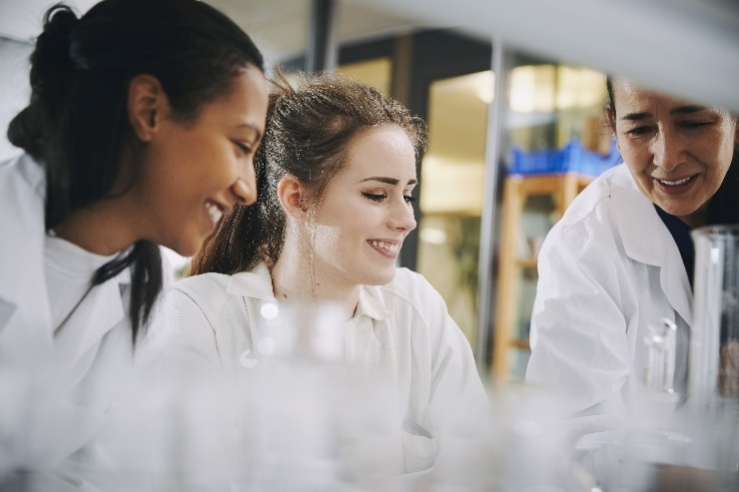
- Basic Healthcare
- Phlebotomy
- Intro. to medical lad. technology
- Urinalysis and body fluids
- Hematology and hemostasis
- Immunology
- Clinical Chemistry
- Immunohematology
- Microbiology and Parasitology

Minimum Requirements:

Applicant must possess a license as a med lab tech in the state of Florida with a bachelor's degree and three (3) years of technical training in the program field as a generalist.

Able to professionally communicate in verbal and written English.

Proficient in MS Office (Word, Excel, PowerPoint) and other business tools such as Skype and Microsoft Teams.

Able to support a diverse and inclusive work environment.

Be excited to train the next generation of lab technicians and work cooperatively with students, faculty, and staff members as well as clinical site personnel.

CONTACT:
Anna Cantelmo
MCLT Instructor/Clinical Coordinator
Erwin Technical College
813-769-5180, x256
anna.cantelmo@hcps.net​

